Assignment 3/4 SQL

Total points: 100

This assignment should be completed individually. For each problem, submit your SQL statements and a screen shot of the SQL results in a single Word document or pdf file. Submit the file via eLearning.

I recommend creating a new user and workspace named after your netid, log in as that user and load the database script facts.sql (provided in this week's assignment folder). Before you attempt to write any SQL queries, familiarize yourself with the database structure and data. I have provided a relational diagram and sample data for this database.
Write queries to address each of the problems below. Submit both the SQL statements and the screen prints of the outputs from Oracle. (2 points for the screen shots). Be sure the workspace name is included in your screen shots!!!
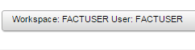
FACT Description and ERD
The CIS Department at Tiny College maintains the Free Access to Current Technology (FACT) library of eBooks. FACT is a collection of current technology eBooks for use by faculty and students. Agreements with the publishers allow patrons to electronically check out a book, which gives them exclusive access to the book online through the FACT website, but only one patron at a time can have access to a book. A book must have at least one author but can have many. An author must have written at least one book to be included in the system, but may have written many. A book may have never been checked out, but can be checked out many times by the same patron or different patrons over time. Because all faculty and staff in the department are given accounts at the online library, a patron may have never checked out a book or they may have checked out many books over time. To simplify determining which patron currently has a given book checked out, a redundant relationship between BOOK and PATRON is maintained.
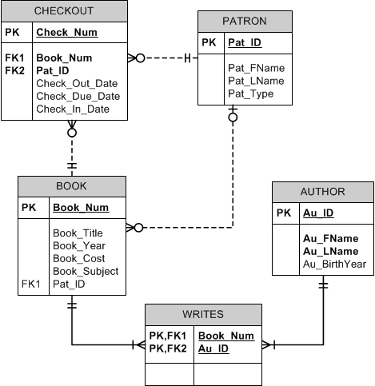

- Create a new table to track the Library location. – Screen shot not required
(6pts)

LIBRARY (lib_id, lib_name, lib_address, lib_city, lib_state, lib_zip)

LIB_ID is the library id – it is an auto generated number. (you should create a sequence number called lib_id_seq, start with 1001 and increment by 1.)
LIB_ID is the primary key.
LIB_NAME, LIB_ADDRESS, and LIB_CITY is between 1 and 35 characters.
LIB_STATE is 2 characters – default to TX.
LIB_ZIP is 5 numbers. Check for one of the following zip codes – 75081, 75080, 75082, 75079, 75078

- Insert the following records into the LIBRARY table – Display the rows after they have been insert into the table. (5 pts)

1000, JFK Library, 800 West Campbell Road, Richardson, TX, 75080
1001, MLK Library, 105 King Blvd., Richardson, TX, 75081
1002, Hoover Library, 932 Arapaho St., Richardson, TX, 75080
1003, Perot Library, 1523 Perot St., Plano, TX, 75082
1004, Bush Library, 2456 W St., Dallas, TX, 75079

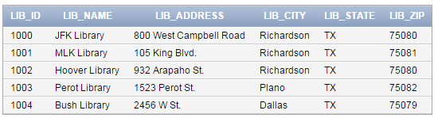

- There is a 1:M relationship between LIBRARY and BOOK. Alter the BOOK table, add lib_id as a foreign key. (4 pts) Screen shot not required

- Update all the Checkout records by updating the year to 2016. (HINT: Use the ADD_MONTHS function). (5 pts) Screen shot not required

- Due to inflation, the cost of all books published in 2014 will increase by 6%. Write a single SQL command to increase all book costs by 6%. (4 pts) Screen shot not required

- Write a query that will display all the Books that were published in 2016. Display the book year, book title, book subject, author last name, and author first. Sort the records by book title. The output should be formatted as follows (Book Title (year), Book Subject, Author Name) see output below. (5 pts)
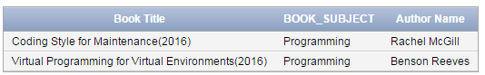

- Write a query to display the book title, book year, book subject , and book cost for all books that are either Database or Programming books and that have a replacement cost that is greater than $50. Sort the results in ascending order by Subject then cost. (4 pts)

- Write a query to show the min, max, and average replacement cost for all books. (4 pts)
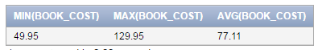
- Write a query to display the book subject and the number of books as “# Books” in each subject, order by the subject. (5 pts)

- Write a query to display the patron type and the number of patrons as “# of Patrons” in each type, order by the number of patrons in descending order. What are some of the problems with the way the data is entered? How could you avoid those problems at the DBMS level? (5 pts)

- Write a query to calculate the age of each author – display the author name as follows (Lastname, Firstname), their birth year, and their age as “Age”. Round the age to 0 places – order by age in descending order. Do not display those authors who do not have a birthyear recorded. (HINT: Use sysdate to get the current date, and to_char to extract out the current year). (5 pts)

- Which books have been checked out more than 7 times? Show the book_title, bok_num and the # of times checked out. Show the query and the result set. (6 pts)

- Write a query to display books that have the word “database” in the title regardless of how it is capitalized. (4 pts)

- Write a query to display the total number of books as “# of Books”. (4 pts)

- Which patrons have checked out more than 2 books? Display the patron name, patron type, and number of books. (6 pts)

- Write a query to display the patron id, book title, and days kept for each checkout. “Days Kept” is the difference from the date on which the book is returned to the date it was checked out. (6 pts)

- Write a query to display all the books that are currently checked out. Display the book title, patron last name, due date, and # of days remaining until it is due. (6 pts)

- Write a query that will display all the books that are overdue. Display the book title, patron last name, due date, and days overdue. (6 pts)

- Write a query that will which authors have written more than 2 books. Display the author first name, last name, and “# of Books Written”. (6 pts)

- Write a query that will list all the books that have never been checked out. List the book number, book title and subject. (4 pts)

BONUS:

B1. Write a query that will display the average cost of books within a given subject and the difference between the books cost and the average cost. Display the book number, book title, book subject, average cost, and difference. Sort by book subject. (5 pts)

B2. Write a query that will display the patron id, pat last name, and number of times that patron has checked out a book and the number of different books the patron has ever checked out. For example, if the patron has checked out the same book twice that would count as two checkouts but only 1 book. Sort the results in descending order by number of books and then in descending order by number of checkouts, then in ascending order by patron last name. (6 pts)

B3. Write a query that will display the average days kept for books in each category. Display the subject and the average days kept. (4 pts)

